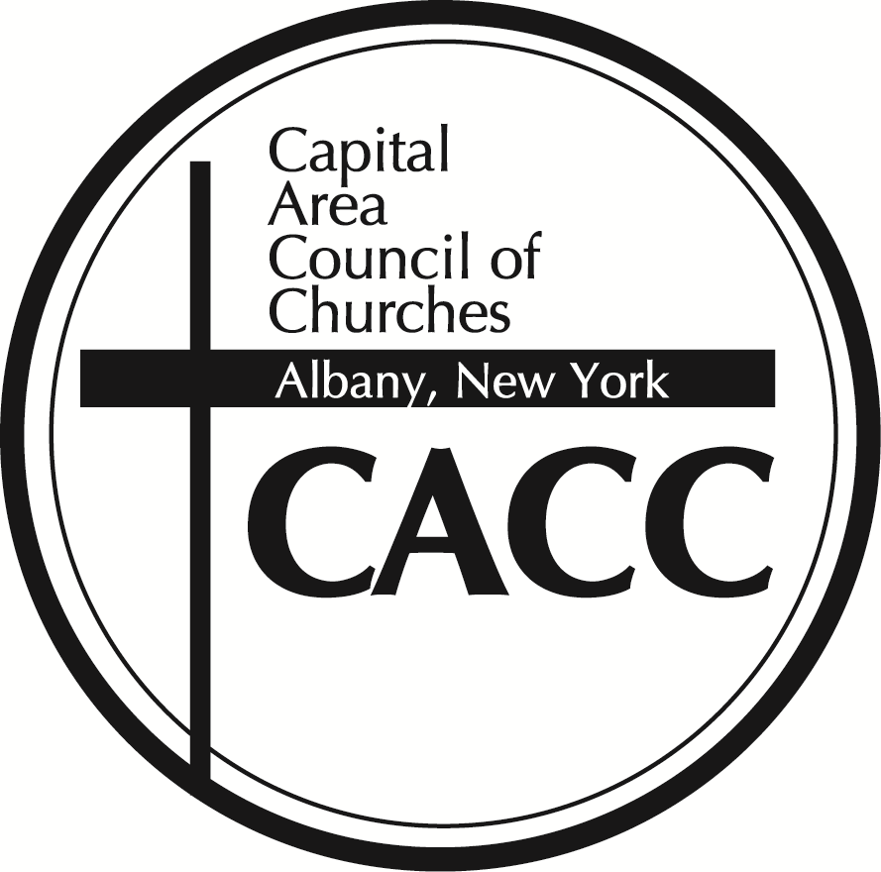

**FOR IMMEDIATE RELEASE** **Contact:** Peter Crasto-Donnelly

Executive Director

**Phone:** (518) 462-5450 or (315) 853-1517

**Email:** capcareacc@gmail.com

**CACC Celebrates our New Location and Ribbon Cutting**

Albany, New York, January 6th, 2025

The Capital Area Council of Churches is a network of 90 churches that come together in fellowship and service. If you've heard of the CROP Walk, the Rev. Dr. Martin Luther King, Jr. Interfaith Celebration, or the Emergency Overflow Homeless Shelter you are familiar with our quiet presence and impact in this community.  The Council is holding a ribbon cutting and press event on January 6th, 2025 from 12 PM – 2 PM at The First Church in Albany, 110 North Pearl Street, Albany, NY 12207.

Council Leadership will provide comments at 1 PM thanking First Church for welcoming the Council to their new home and promoting four upcoming events that promote Christian Unity:

* **Ecumenical Witnesses of Baptism Renewal Service** - Sunday January 12th, 2 PM, St. Matthew’s Roman Catholic Church in Voorheesville, 25 Mountainview St, Voorheesville, NY 12186. When a church is hosting a baptism, Witnesses from other churches are invited to share an ecumenical blessing over the newly baptized. The Renewal Service is when Witnesses join or renew their commitment in the upcoming year. Witnesses commit to attending two baptisms a year.
* **Rev. Dr. Martin Luther King, Jr. Interfaith Celebration** - Wednesday January 15th, Congregation Beth Emeth, 7 pm, 100 Academy Rd, Albany, NY 12208. This interfaith memorial service is held each year on January 15th, Rev. Dr. Martin Luther King, Jr.’s birthday and brings the community members together to reflect on Dr. King’s legacy. It also includes a time to collect donations for the Rev. Dr. Martin Luther King, Jr. Scholarship for high school seniors. The program aims to fundraise $20,000 and awards $4,000 scholarships.
* **A Church Unity Octave Ecumenical Service** - hosted by the Roman Catholic Diocese of Albany (RCDA) Commission on Ecumenical and Interreligious Affairs - Wednesday January 22nd, 12:15 PM, RCDA Pastoral Center, 40 N Main Ave, Albany, NY 12203. This Ecumenical Service, based on materials from the Graymoor Ecumenical and Interreligious Institute, invites Christians to worship together in prayer for Christian Unity. CACC Executive Director Peter Crasto-Donnelly is presiding and Bishop of the Episcopal Diocese of Albany The Rt. Rev. Jeremiah D. Williamson will be preaching.
* **Annual Assembly** – Wednesday February 12th, Bethany Reformed Church, 760 New Scotland Ave, Albany, NY 12208, 6 PM Networking, 6:30 PM Annual Report, 7 PM program. Member Churches will share about key programs or ministries.

CACC will provide light refreshments for the Open House. Interested parties should register their intent to attend at <https://www.capareacc.org/2024/12/cacc-open-house-jan-6th-2025/> Other ways to register are to email capareacc@gmail.com or call the office at (518) 46-5450. Questions can be directed to Peter Crasto-Donnelly at (315)853-1517. Additional information can be found on the CACC website at [www.capareacc.org](http://www.capareacc.org).