Capital Area Council of Churches
646 State Street, Albany, New York 12203

Rev. Dr. Martin Luther King, Jr. Scholarship Application
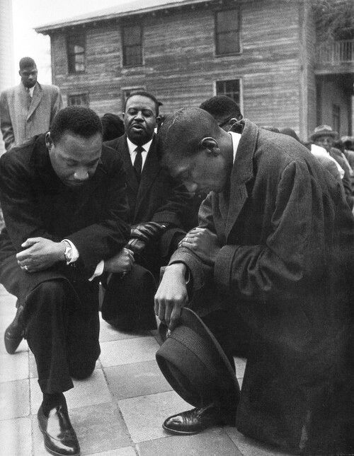
Application and all related material must be postmarked no later than March 31st
ALL INFORMATION SUBMITTED WILL BE TREATED CONFIDENTIALLY

Capital Area Council of Churches
646 State Street, Albany, New York 12203
Rev. Dr. Martin Luther King, Jr. Scholarship Application
History and Guidelines
The Rev. Dr. Martin Luther King, Jr. Scholarship was established in 1973 to honor the memory of the life and work of Dr. King and to preserve the legacy of the nonviolent human rights movement as it was expressed in his life and teachings.
The Rev. Dr. Martin Luther King, Jr. Committee is hopeful that all recipients will explore how problems such as racism, sexism, classism, militarism, ageism, and prejudice in our schools, cities, nation, and world, can be confronted effectively and peacefully.
Eligibility requirements for the Rev. Dr. Martin Luther King, Jr. Scholarship:
- A high school senior or high school graduate preparing for the first year of college;
- A resident of, or a member of a religious institution in the capital area;
- Acceptance and maintain good standing at an accredited college or university.

Submission of the following are required to be postmarked no later than March 31st:
- Completed application form.
- Academic record - High School transcript, GPA/Ranking
- Copy of the student financial aid summary and FAFSA form.
- Recommendation from teacher or guidance counselor; must have personal knowledge of applicant and evidence of ability to compete on a college or university level.
- Recommendation from religious leader or community leader; must have personal must have knowledge of applicant and evidence of ability to compete on a college or university level.
- 500 word essay, two typed pages, double-spaced with at least two referenced sources
Essay Guidelines: The teachings of Rev. Dr. Martin Luther King, Jr. focus on racial justice and nonviolent social change. Please write an essay in 500 words on what you understand about those teachings and how you might promote his ideals in your life. Your essay will be judged on:
- Creative content – Did the applicant utilize a unique prospective or point of view?
- Idea development & focus – Was the idea developed to the fullest extent? Was the essay coherent and rational? Did the applicant remain focused?
- Writing style – Includes format, spelling, punctuation.
Awards for the Rev. Dr. Martin Luther King Scholarship are given based on the following criteria:
- How applicant has implemented and plans to implement the goals of Rev. Dr. Martin Luther King, Jr. as described in his/her essay.
- Financial need
- Evidence of Service provide specific examples of your service in each of these 3 areas and explain how your service reflects the ideals of Rev. Dr. Martin Luther King, Jr.
  - School
  - Faith community
  - Society
- Academic record
- Personal goals
Interview Process: Finalists will be expected to take part in an interview with the Rev. Dr. Martin Luther King, Jr. Committee Members. This interview is a significant determining factor in awarding the Rev. Dr. Martin Luther King, Jr. Scholarship.
Capital Area Council of Churches
646 State Street, Albany, New York 12203
Rev. Dr. Martin Luther King, Jr. Scholarship Application
Application and all related material must be postmarked no later than March 31st

Name: _____________________________________ Date of birth: _________ Phone: _______________

Address: _____________________________________ City: _______________ State: _____ Zip: ______

E-mail Address: ________________________________________________________________________

Religious affiliation and/or membership: ___________________________________________________

High School GPA/Ranking_________ Honors/Awards (Please indicate year received)
____________________________________________________________________________________________________________________________________________________________________________________________________________________________________________________________________________________________________________________________________________________
_____________________________________________________________________________________

Hours/Week School Activity Leadership Role if any
9th grade ___________ _____________________________________ ___________________

10th grade ___________ _____________________________________ ___________________

11th grade ___________ ______________________________________ ___________________

12th grade ___________ ______________________________________ ___________________

Work Experience

Employer Position Held Employment Dates

__________________ ___________________ ___________________

__________________ ___________________ ___________________

__________________ ___________________ ___________________

Community Service

Organization Duties Dates

__________________ ___________________ ___________________

__________________ ___________________ ___________________

__________________ ___________________ ___________________

Capital Area Council of Churches
646 State Street, Albany, New York 12203
Rev. Dr. Martin Luther King, Jr. Scholarship Application
Hobbies and interests: ______________________________________________________________________
Vocational interests: _______________________________________________________________________
College or university you plan to attend: ___________________________________________________
Have you been accepted? (Check one) [ ] Yes [ ] No Will you be a full time student? (Check one) [ ] Yes [ ] No
Other immediate family members attending college at the same time:
Name ______________________________________ ______________________________________
Relationship to you ____________________________ ______________________________________
College or University attending: __________________ ______________________________________
Parent/Guardian’s Employer ____________________________________________________________
Provide Completed FAFSA ____

Applicant Signature: _______________________________________________Date________________

Parent/Guardian Signature: __________________________________________Date________________

Checklist for submission - All must be completed and postmarked no later than March 31st:
- Met the Eligibility REQUIREMENTS.
- Submission of the completed application.
- Academic record - High School transcript, GPA/Ranking
- Financial Aid Summary, copy of FAFSA form and complete financial disclosure.
- Recommendation from teacher or guidance counselor.
- Recommendation from religious or community leader.
- Goals explained in 500 word essay reflecting ideals in essay of Dr. King.
- Specific examples of school, faith community, and society service reflecting ideals of Dr. King.

Finalists will be interviewed to determine the awarding of the Rev. Dr. Martin Luther King, Jr. Scholarship.

ALL INFORMATION SUBMITTED WILL BE TREATED CONFIDENTIALLY.

revised 1/7/2022

